Name: Rana Ahmed SE-2

Week 4 Lab Report

Microservices and Cloud-Native Design

1. Introduction
In this lab, I built a simple cloud-native system using two microservices: a product-service and an order-service. The goal was to understand how microservices work, how they communicate, and how Docker and Docker Compose help in running and managing them.

2. System Overview
The system consists of two services:
- product-service: provides product data
- order-service: creates orders by requesting product data from product-service
The flow is: Client → order-service → product-service
The order-service depends on product-service to validate products and calculate the total price.

3. Implementation Summary
Both services were implemented using Python Flask. Each service has:
- its own codebase
- its own dependencies
- its own Dockerfile
The services were containerized using Docker and run together using Docker Compose. Environment variables were used to configure service communication.
4. Testing and Results
I tested both services individually and together:
- product-service successfully returned product data
- order-service successfully created orders when product-service was available
Example result:
- Order created with correct product name, quantity, and total price

5. Failure Testing (Resilience)
To test failure behavior, I stopped the product-service container.
Result:
D:\week4-lab>curl -X POST http://localhost:5002/orders -H "Content-Type: application/json" -d "{\"product_id\":1,\"quantity\":2}"
{"message":"Order created","product":"Laptop","quantity":2,"total_price":2400}
After i stopped the product-service container.
D:\week4-lab>curl -X POST http://localhost:5002/orders -H "Content-Type: application/json" -d "{\"product_id\":2,\"quantity\":2}"
{"error":"product-service unavailable"}
Re-running the product-service container
D:\week4-lab>curl -X POST http://localhost:5002/orders -H "Content-Type: application/json" -d "{\"product_id\":1,\"quantity\":2}"
{"message":"Order created","product":"Laptop","quantity":2,"total_price":2400}

- order-service failed to process the request
- it returned an error message (503 service unavailable)
This shows that the system depends on communication between services, and failure in one service affects others.

6. Benefits of Microservices
This lab showed several advantages of microservices:
- Services are independent and can be deployed separately
- Easier to scale individual services
- Clear separation of responsibilities

7. Challenges of Microservices
However, microservices also introduce complexity:
- Services depend on network communication
- Failures in one service affect others
- Debugging becomes harder
- More configuration is required (Docker, environment variables)

8. Cloud-Native Principles Used
This system follows several cloud-native practices:
- Stateless services: no local data storage
- Environment variables: configuration is externalized
- Containerization: each service runs in its own container
- Health checks: used to monitor service status
- Restart policy: services automatically restart if they fail

9. Role of Docker and Docker Compose
- Docker: allowed packaging each service into a container with all dependencies
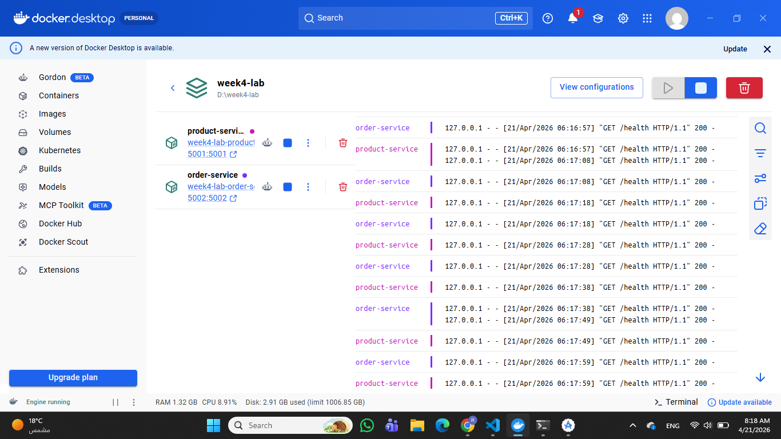
- Docker Compose: managed multiple containers, networking, and service startup
✔ Network week4-lab_default Created 0.1s
✔ Container product-service Started 1.2s
✔ Container order-service Started

It also allowed services to communicate using service names instead of localhost.

10. Architecture Reflection Answers

1. Which parts show benefits of microservices?
The separation into product-service and order-service shows clear benefits of microservices. Each service has a single responsibility and can be developed, deployed, and scaled independently. This is better than a monolith where all logic is tightly coupled in one application.

2. What new complexities were introduced?
Splitting the system introduced network communication between services, dependency management, and configuration complexity.

3. What would break if latency increased or a service became slow?
If product-service becomes slow or unavailable, order-service will also become slow or fail. Since the communication is synchronous, the entire request depends on the response of product-service, which reduces system reliability.

4. Which 12-factor principles are visible?
The implementation follows several 12-factor principles:
Configuration via environment variables
Stateless services (no local storage)
Port binding (services expose ports)
Disposable processes (containers can restart)
Logs handled via Docker

